**Building the test automation framework**

We are using AWS (Elastic compute cloud) to build the test automation system.

Components of a test automation framework

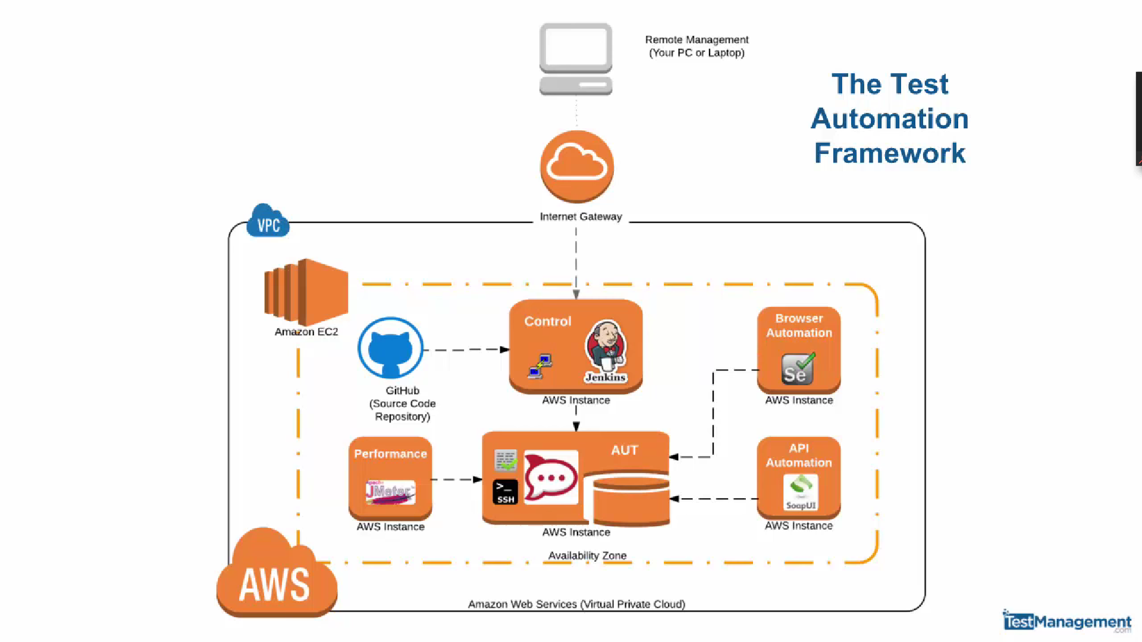

Module 1:

Configuring and running the VM’s that we need for our test environment.

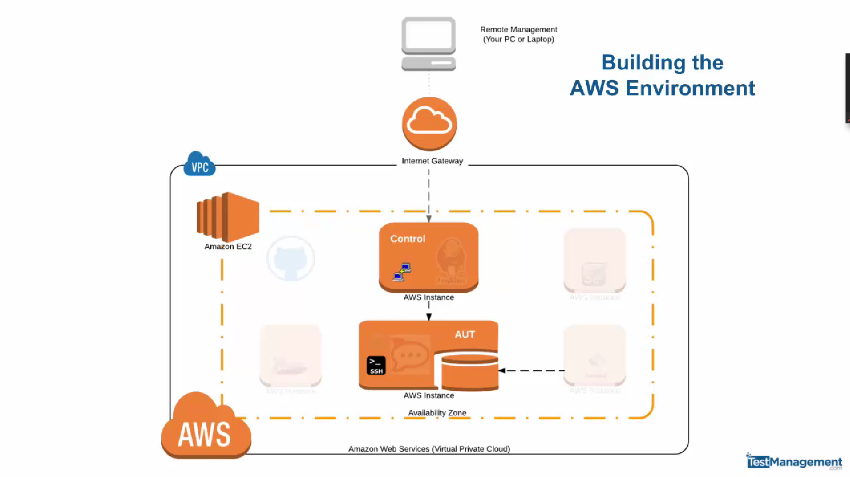

In this above module, we are building a control machine (Windows 2008 box) and a linux machine (Ubuntu) which will run our application under test.

Steps to be followed:

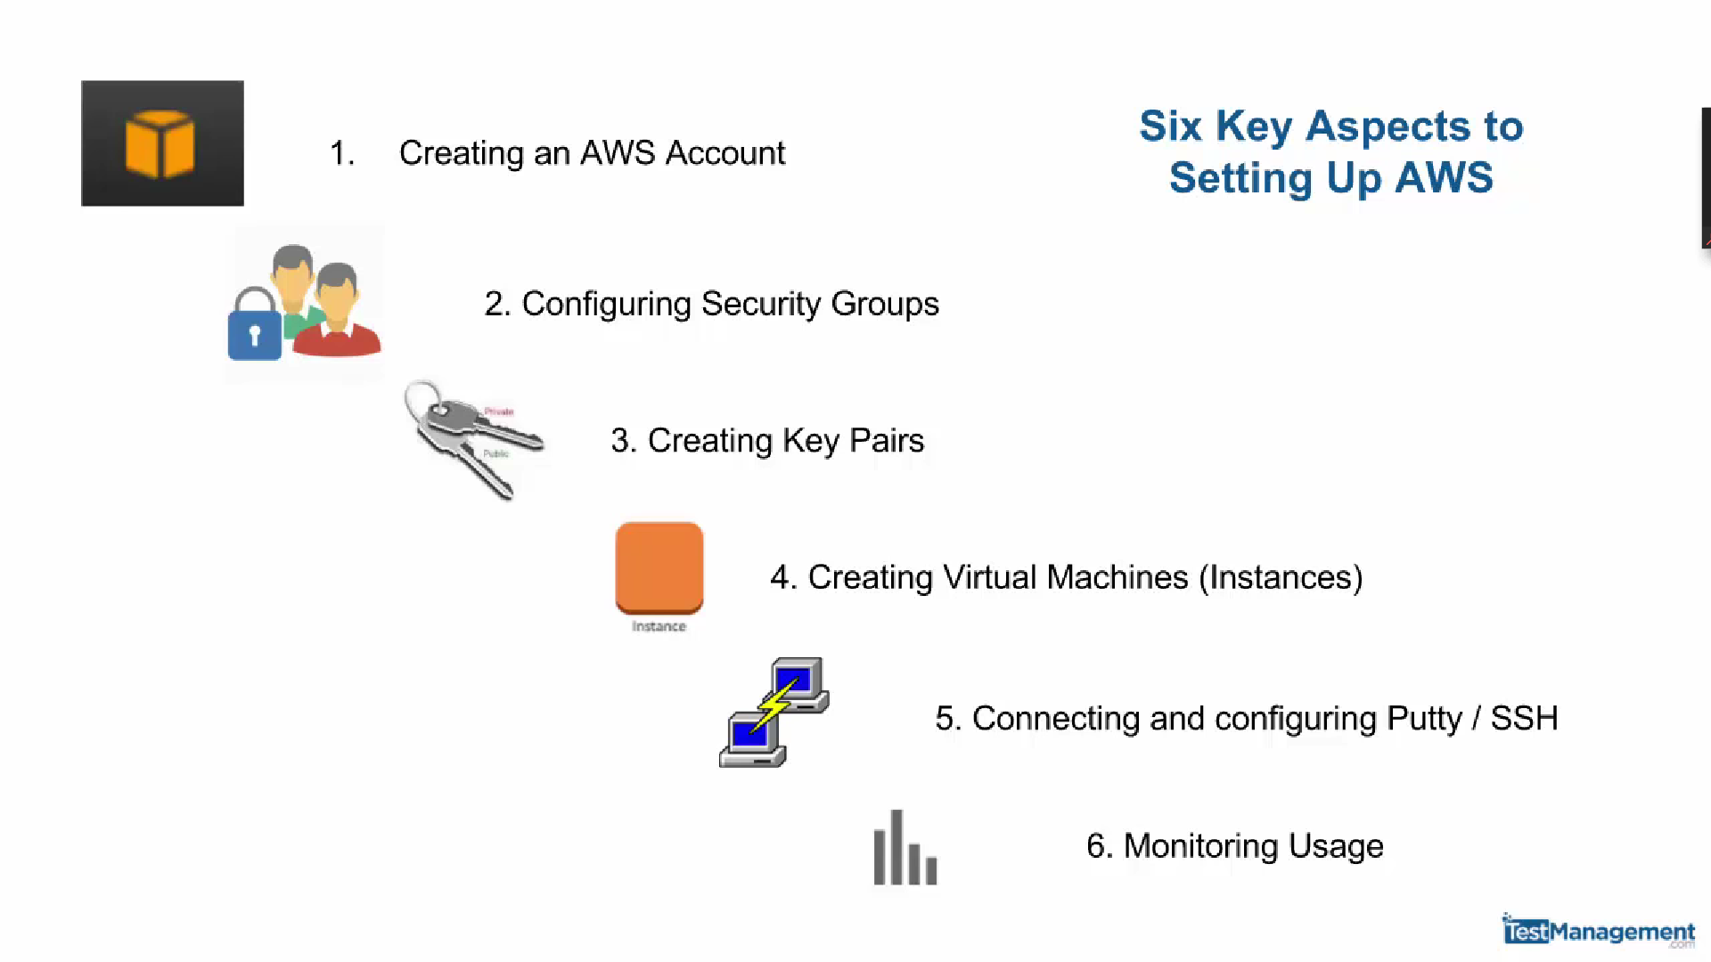

**AWS Services:**

Compute

Storage

Database

Application services

**Zones & Regions:**

**EC2 – Elastic compute cloud:** It is a service that provides resizable computing capacity

After successful creation of AWS account click on services and choose your appropriate choice of service for Ex: EC2, Database, Storage etc.

When you click on any service, the management console of that particular service opens**.**

**Management console of EC2:**

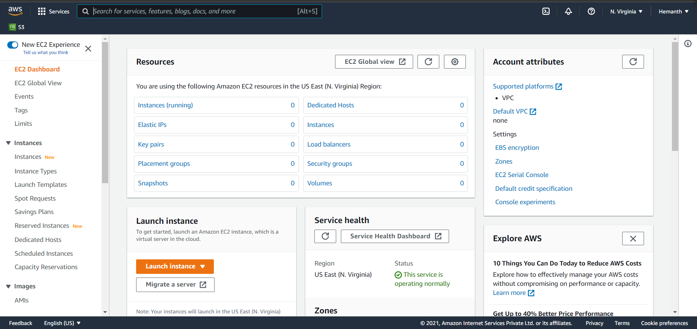

**Create an EC2 instance, configure and then manage those VM’s in amazon cloud.**

**Module 2:**

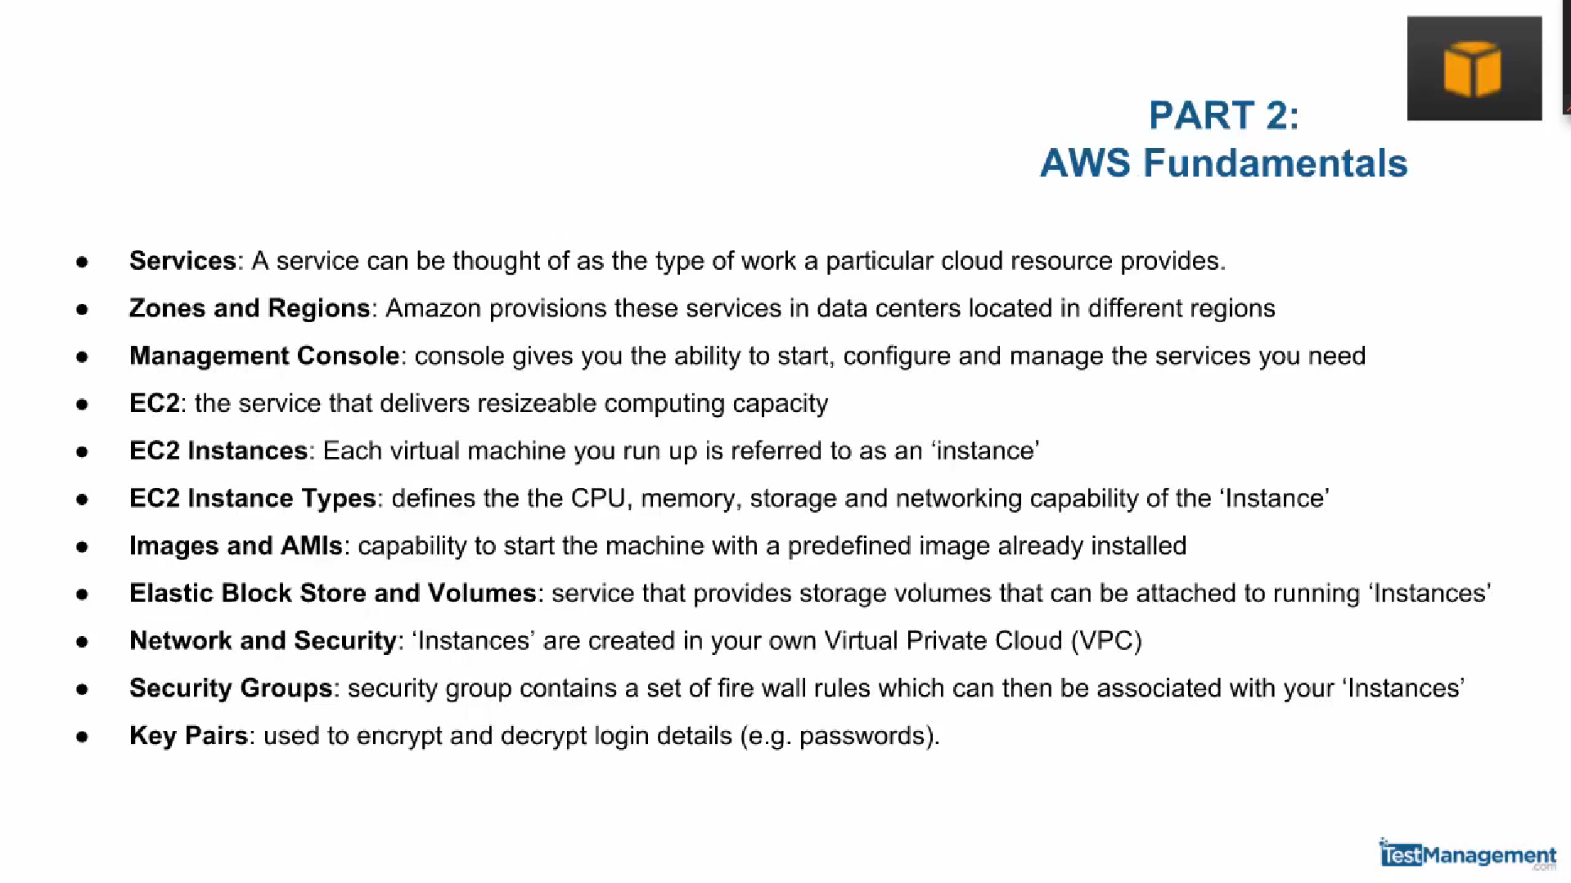

**Instance types:**

Each instance that we run is of a specific type w.r.t Cpu, memory storage, OS, Network capability.

**AMI:**

After launching an instance, amazon provides you with different available AMI.

And Storage can be added through volume option for any VM

Each instance is created in a virtual private cloud(VPC).

By default instances are not given public IP’s or hostnames. Everything is defined by default local VPC addresses. So, if you want public Ip for your instance you need configure.

**Security groups:** Keys to running out instances

AWS uses key pairs to encrypt and decrypt login details.

**Module 3:**

Configuring security groups

We can configure security group for VPC’s

After choosing the region -> Go to EC2 -> Security groups in left side section -> Create a new security group and define inbound/outbound rules

Creating a security group

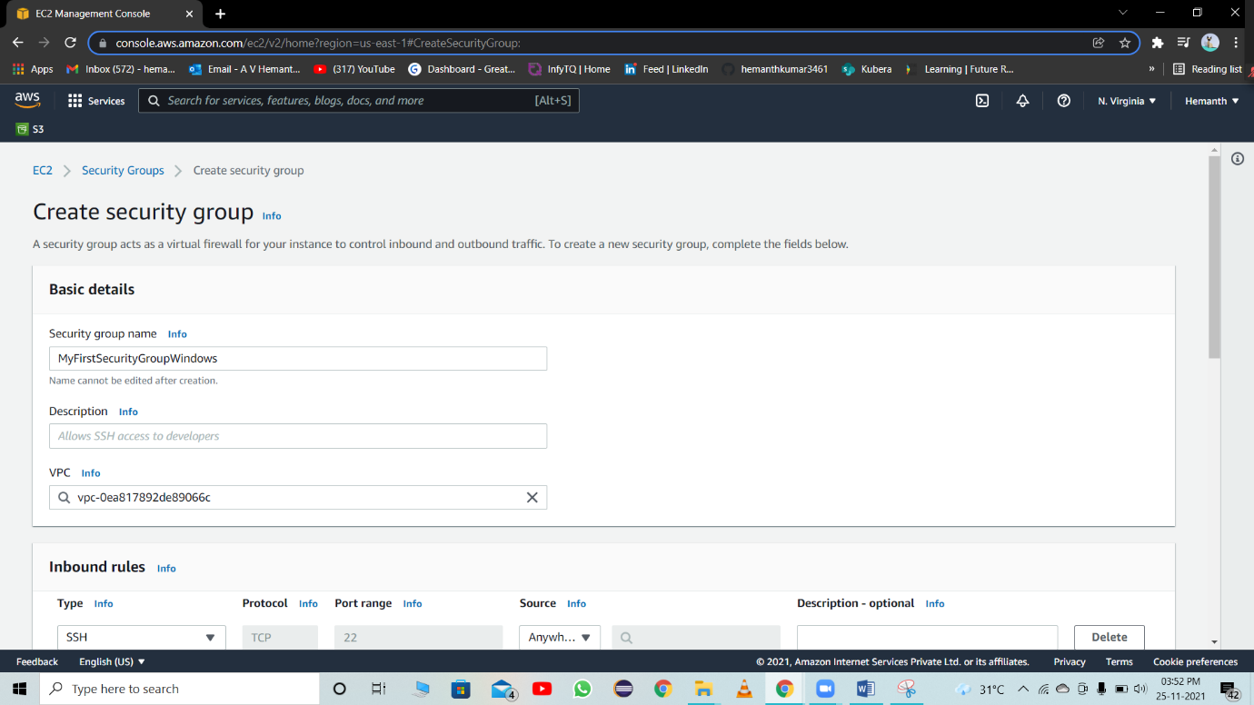

**Provide Inbound/Outbound rules:**

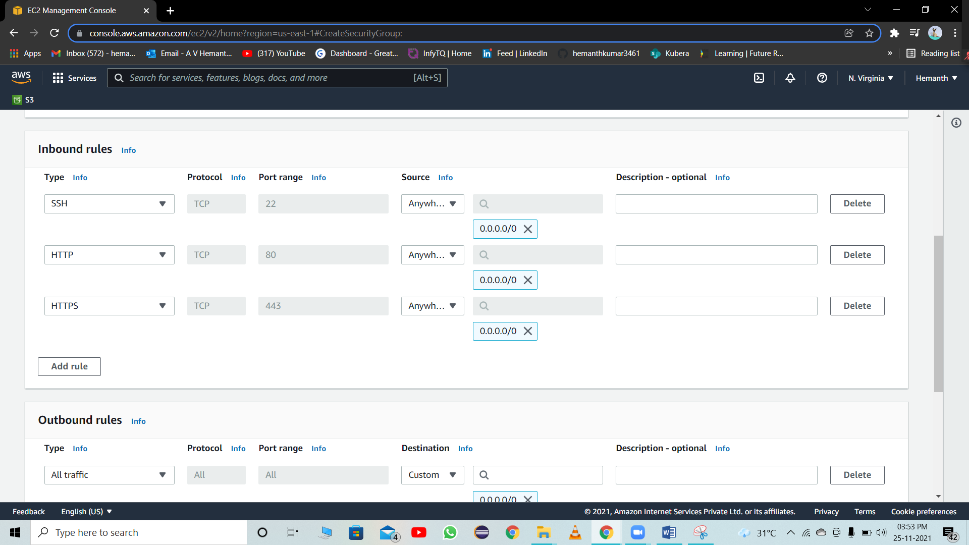

**Click on create security group**

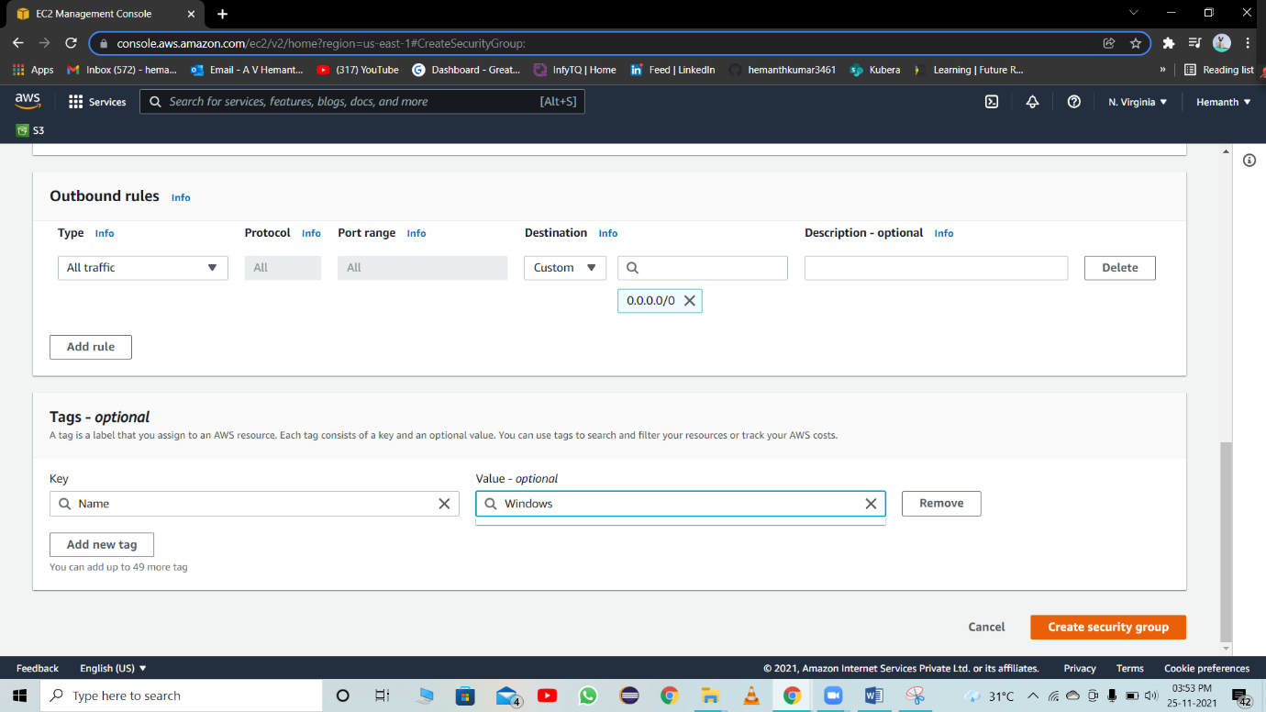

**Security group created**

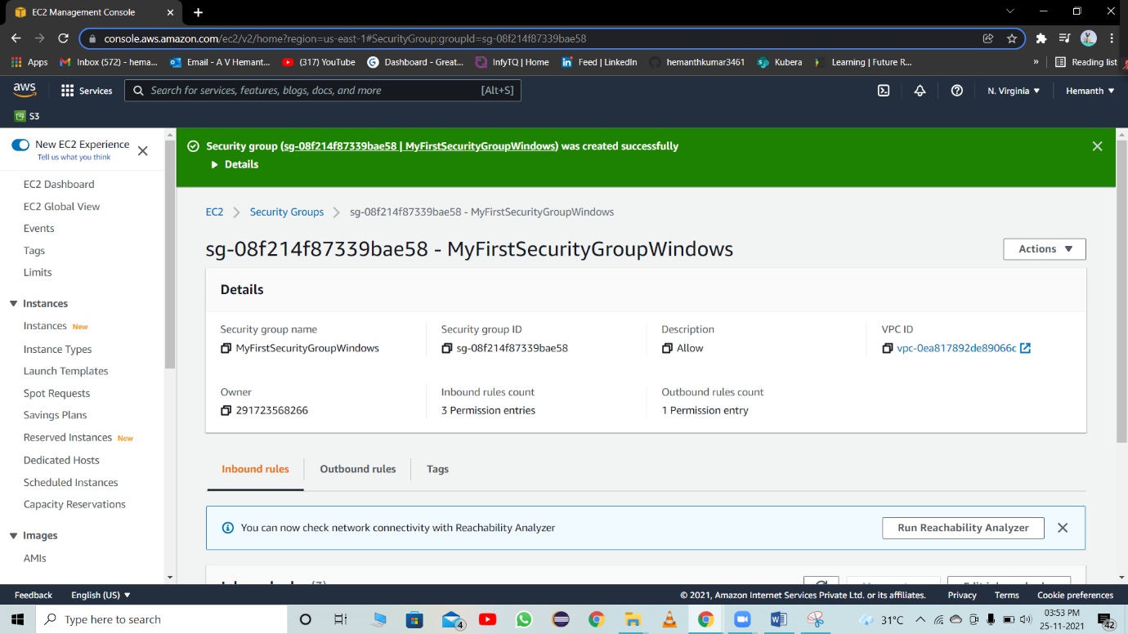

Any instance in this default security group instance can communicate with any other instance present in the same security group

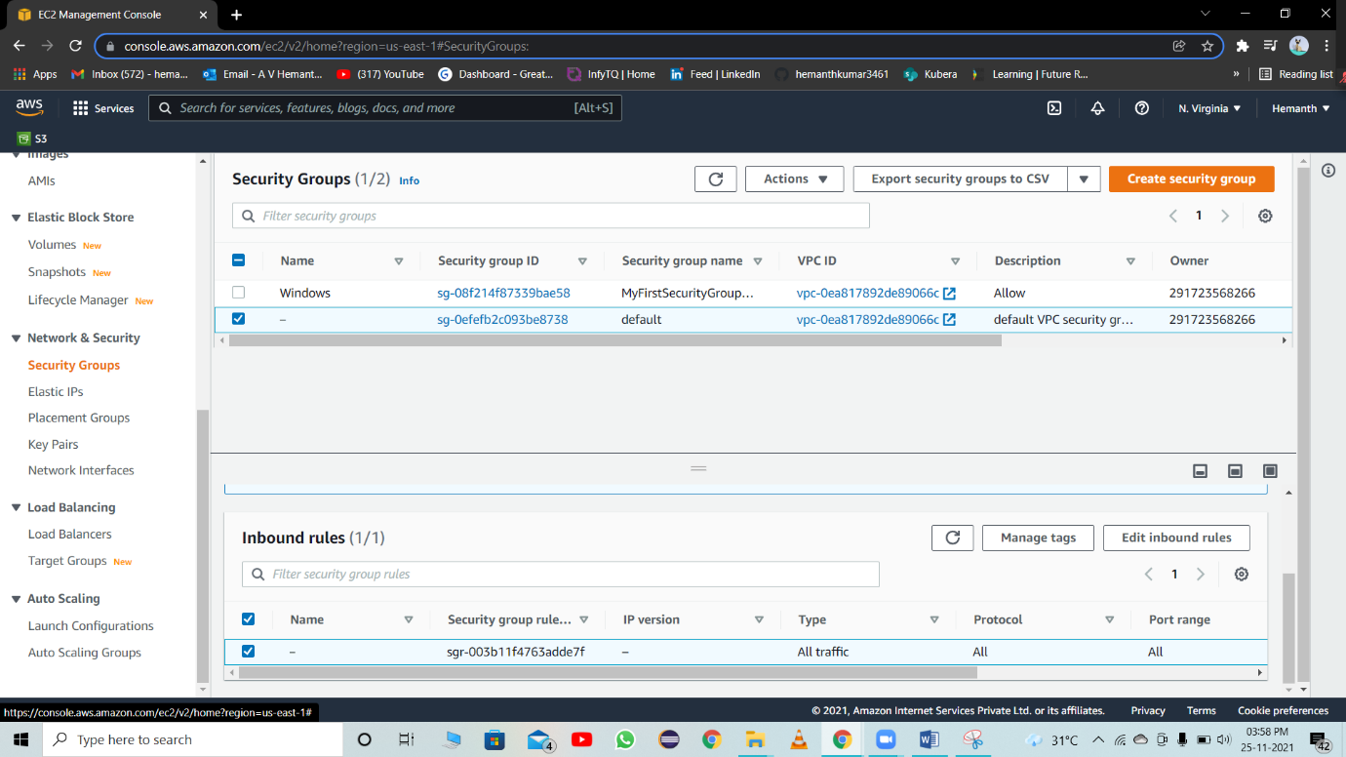

**Module 4:**

**Creating a security key pair**

AWS will encrypt passwords and user will decrypt passwords using private key provided to you.

**Steps:**

**Open EC2**

**Click on key pairs on the navigation panel**

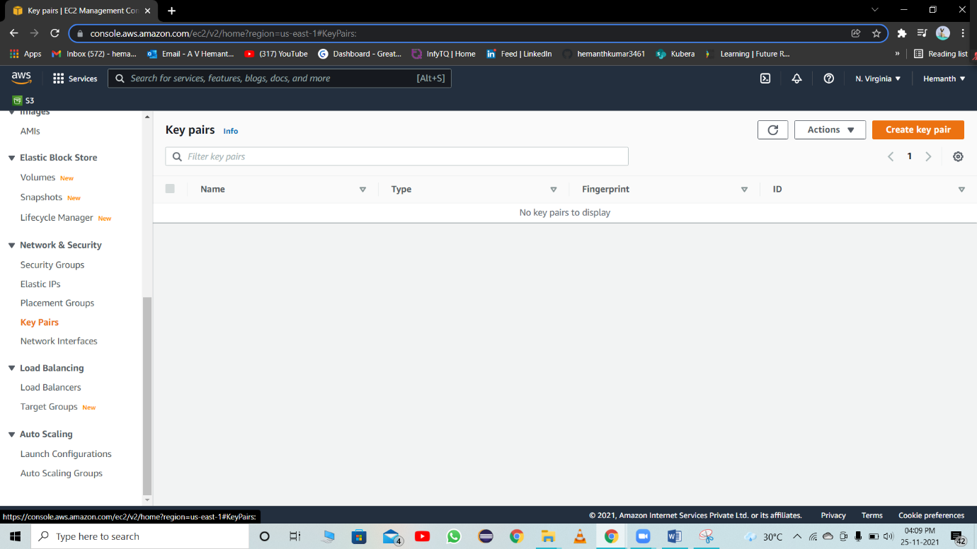

**Provide the details and take PEM file format for your private key**

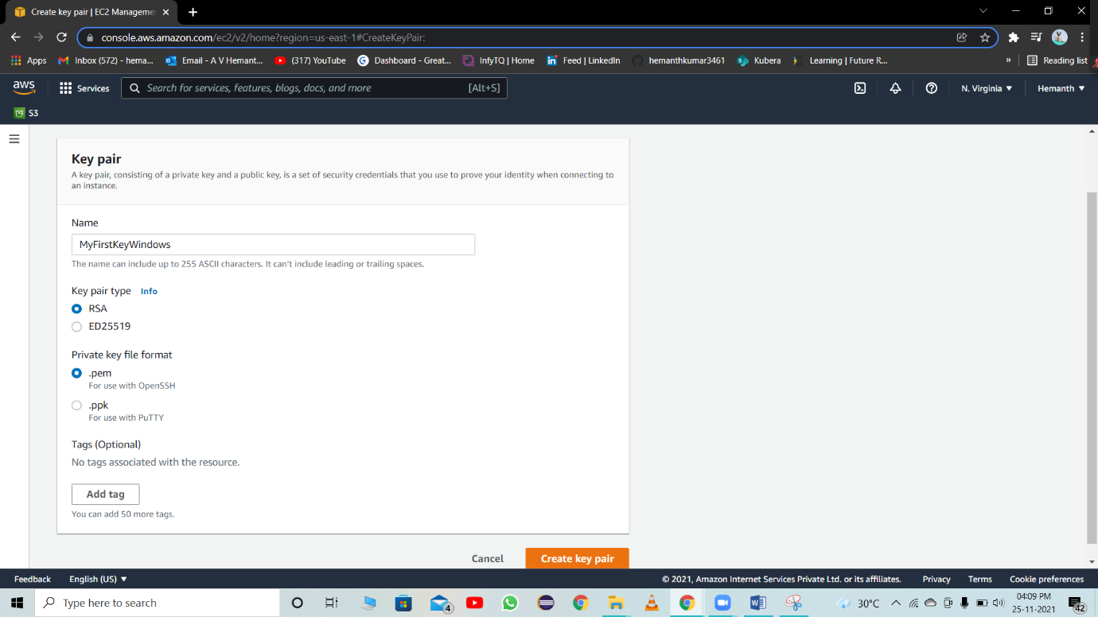

**Once clicked on create, there will be PEM file created**

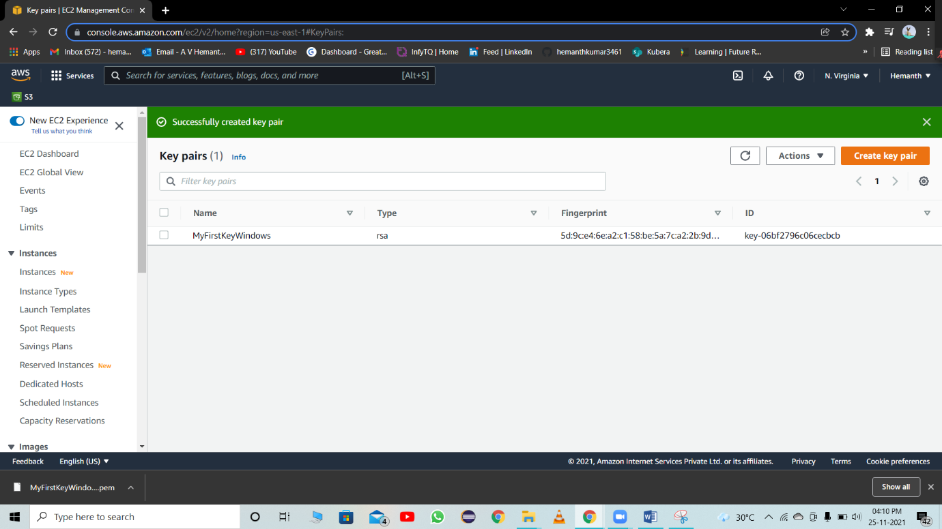

**Module 5 & 6:**

**Running up the windows instance**

1. **AMI**
2. **Instance type**
3. **Security group**
4. **Private key**

**Open EC2 -> Launch**

* **Select AMI**
* **Choose a instance type**
* **Configure instance**
* **Add storage**
* **Add tags**
* **Configure security groups**
* **Review and launch**

**Module 7:**

**Connecting to the windows master machine**

**After launching instance**

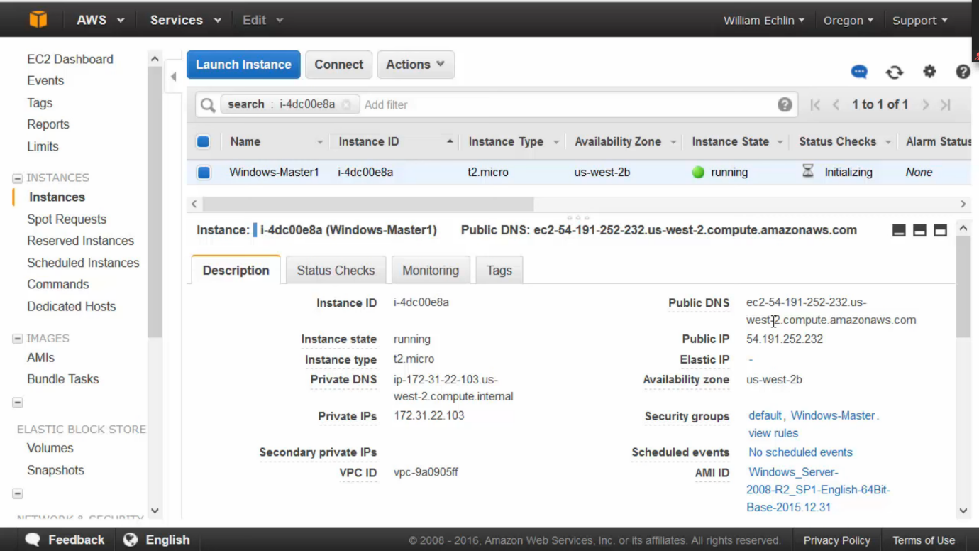

**Right click in instance get windows password**

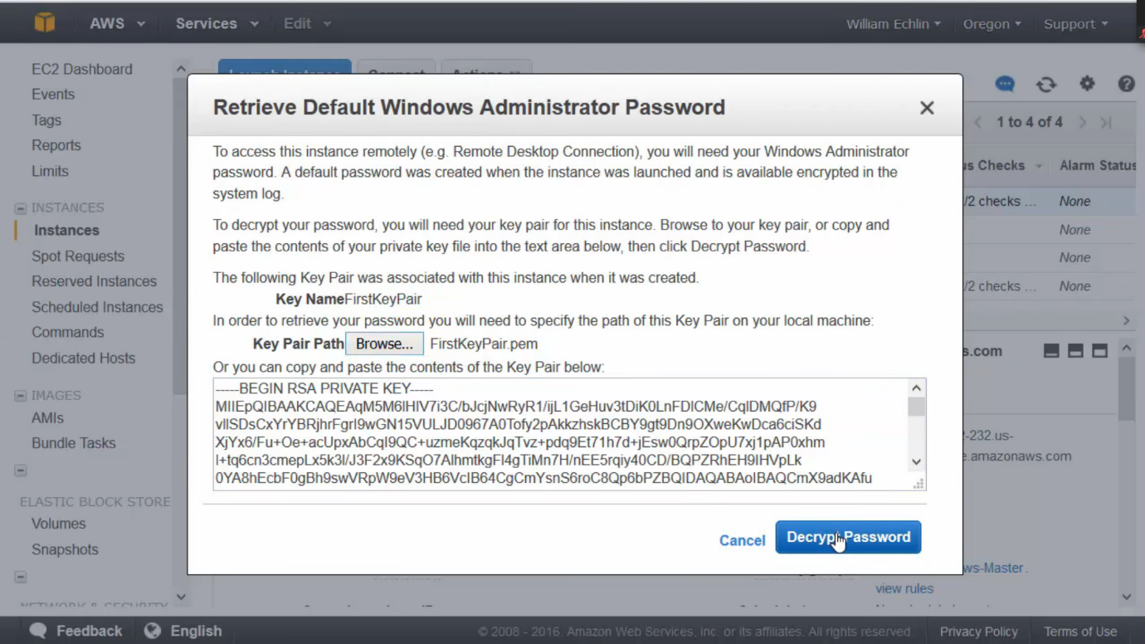

**Configure click on decrypt**

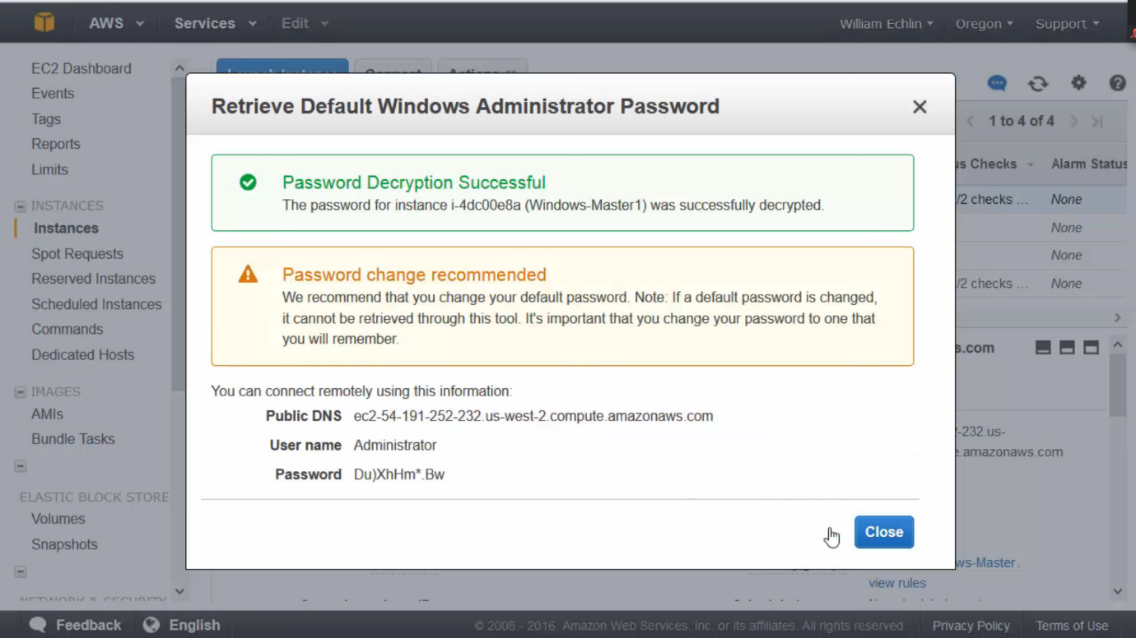

**Now we have access to password**

**Then take this password and right click again on instance or click connect button then provide the password.**

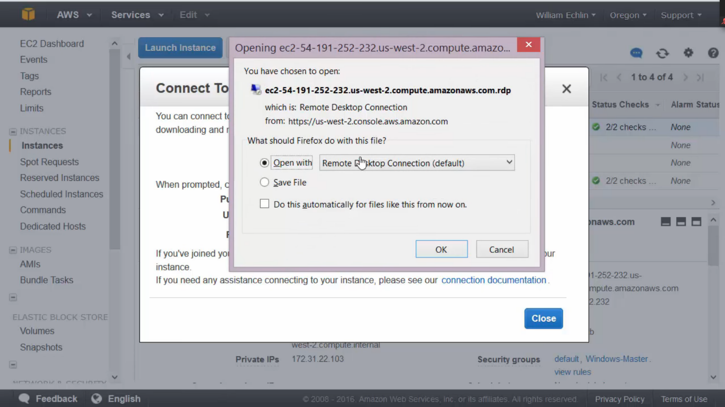

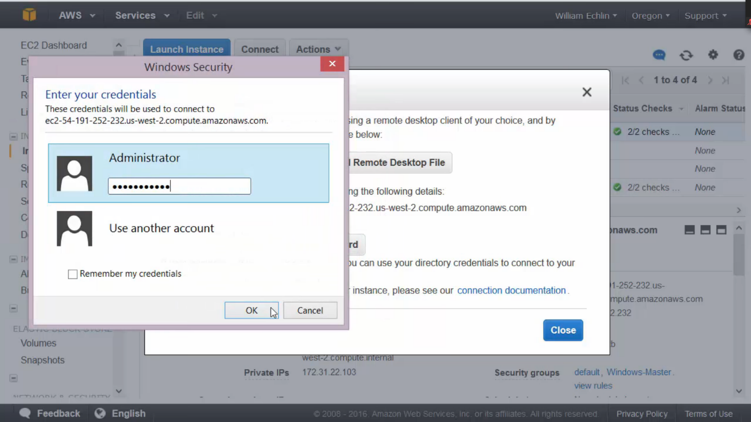

**Windows VM launched**

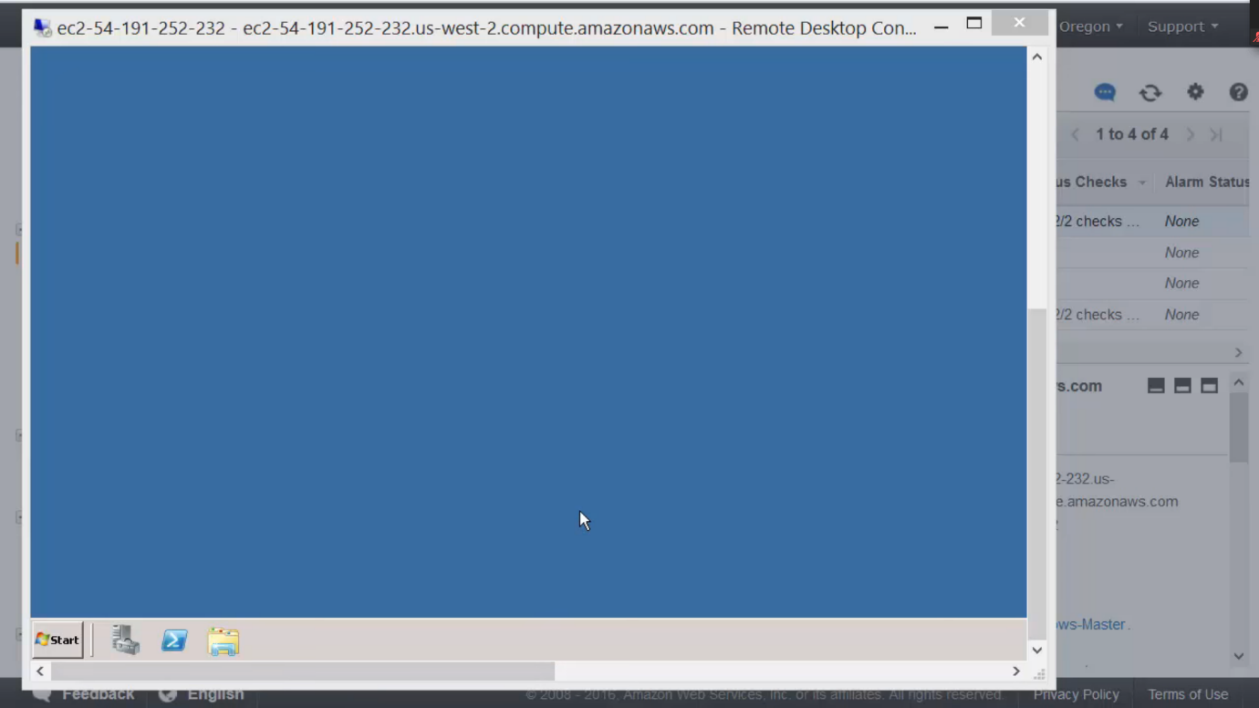

**Module 8:**

**Installing putty for SSH**

**Download putty in VM and provide the PEM and get the PPK file**

Download PuTTY from [www.putty.org](http://www.putty.org)

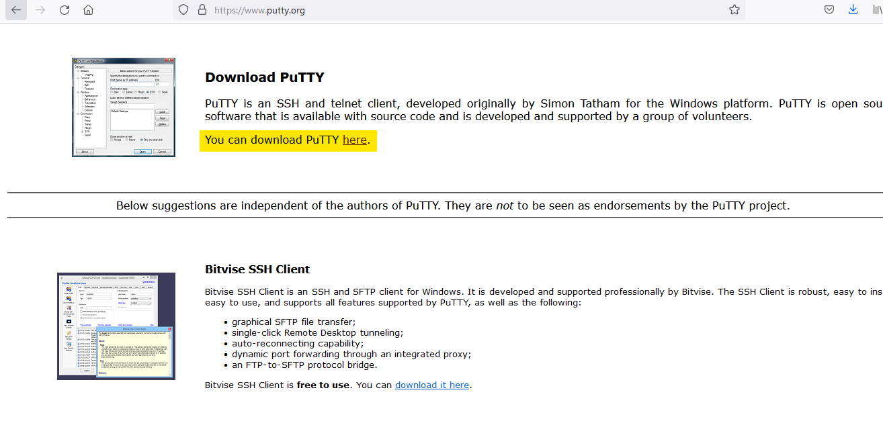

open the puttygen from program files

select load

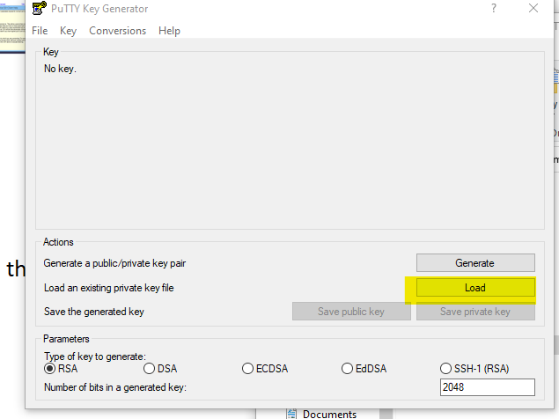

select the pem file you downloaded while launching instance (make sure you select all files)

open the pem file

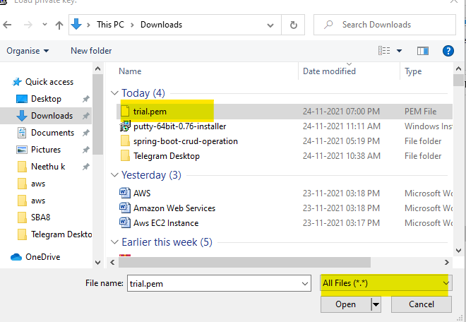

click on save private key

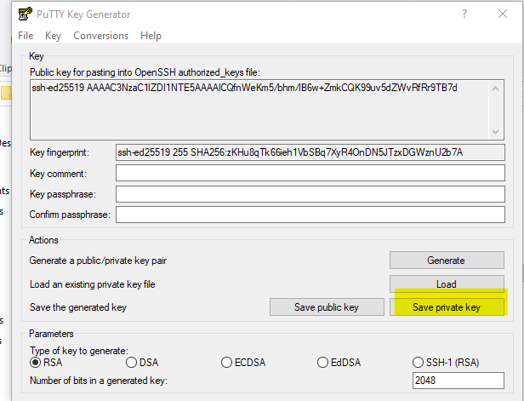

open the putty from program files

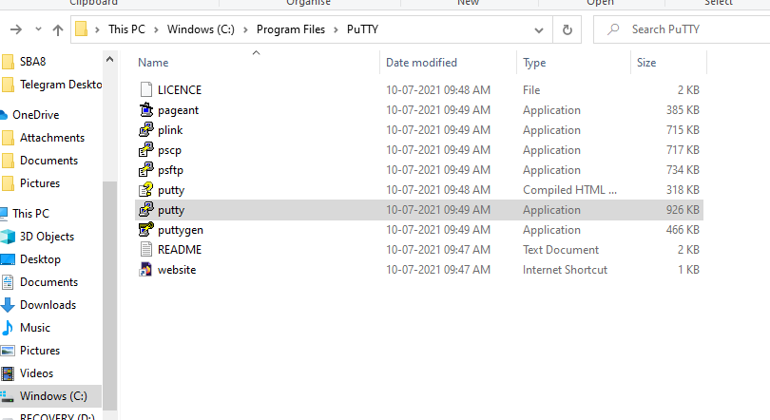

copy paste host name (paste the DNS as host name)

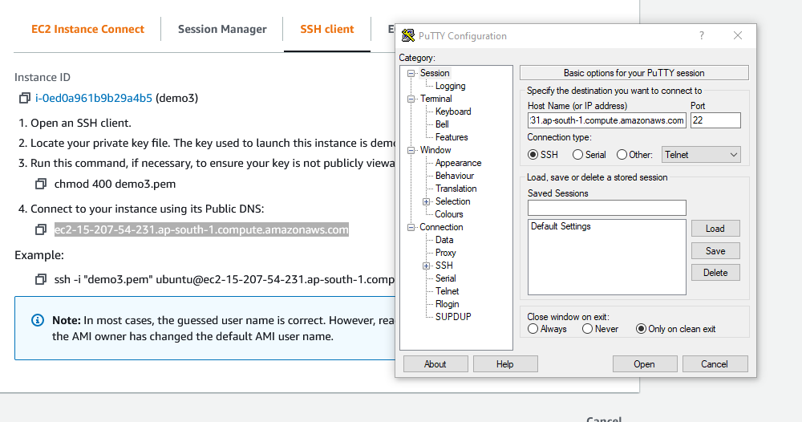

select data 🡪 give user name as ubuntu(as in your eg)

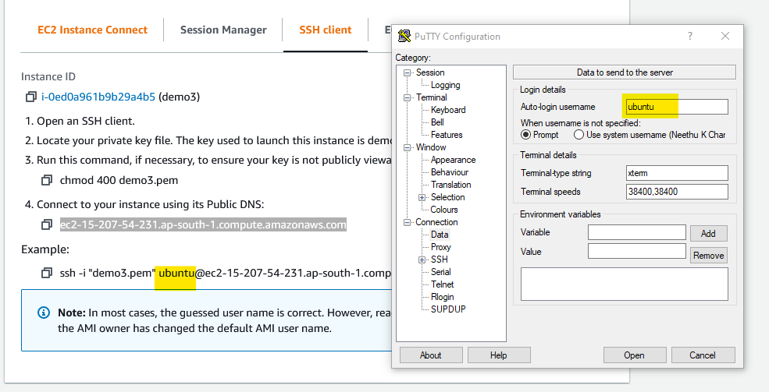

click on SSH🡪 select auth🡪 browse our putty private key🡪 click open

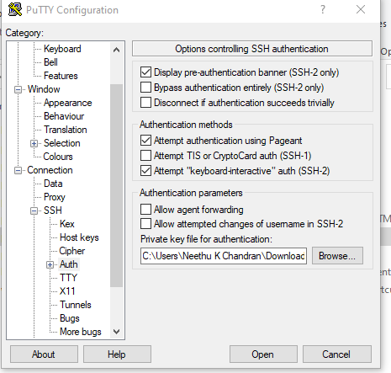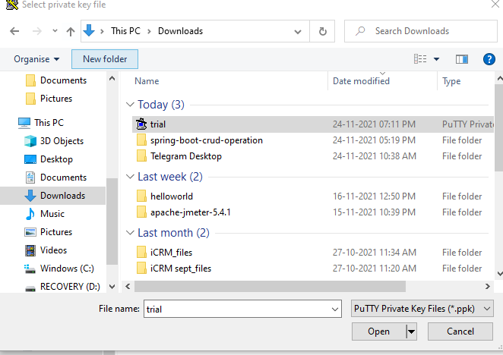

your terminal will be open

**Module 9:**

Connecting to the unix client machine from windows machine

From windows machine we can also connect with Linux machine using putty. This putty acts as connection shell in order to connect to Linux(Machine under test) from windows machine(Control master).

After launching our windows through connect and that opens VM

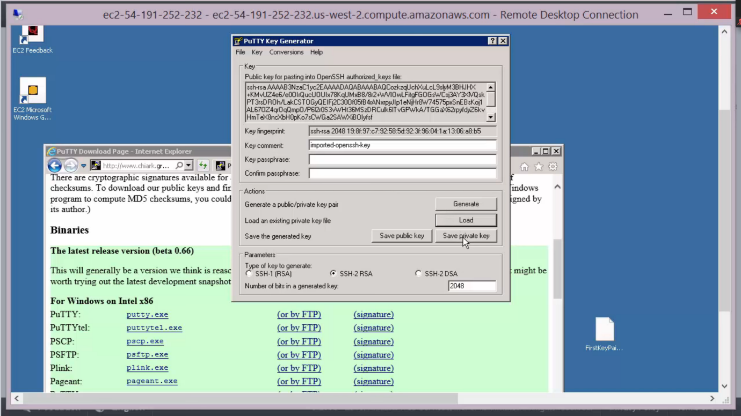

**Open puttygen and convert the imported PEM to PPK in VM**

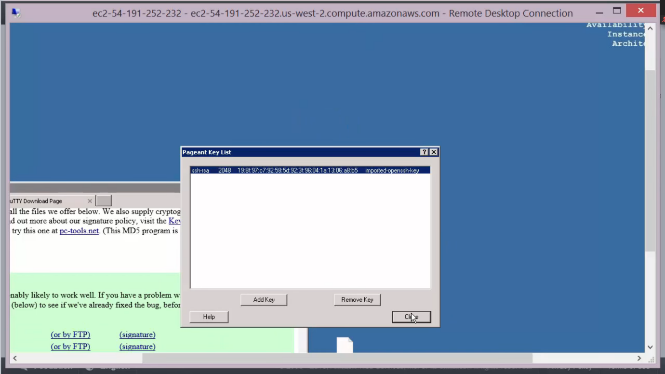

**Choose private Ip of linux machine and paste in window putty**

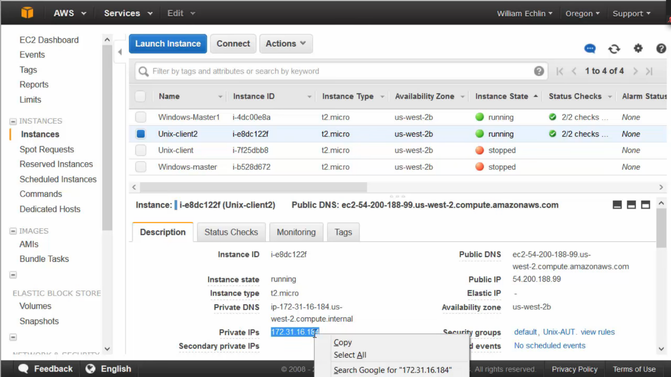

**Configure putty with Linux Ip and other required settings**

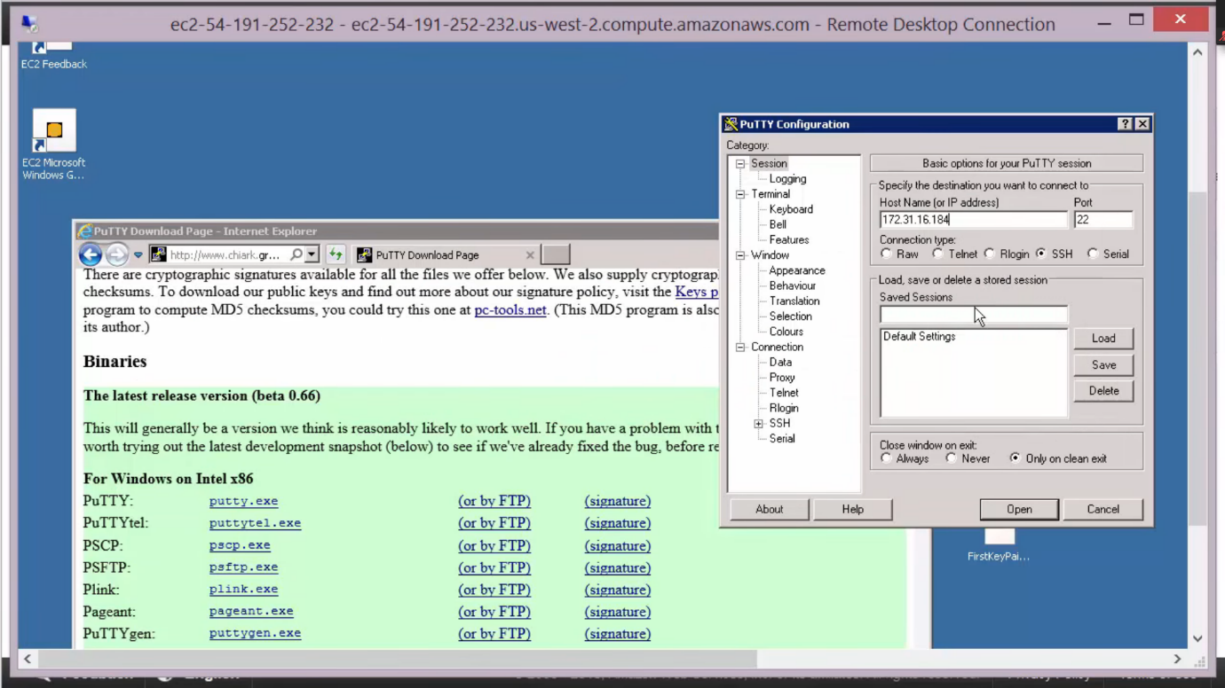

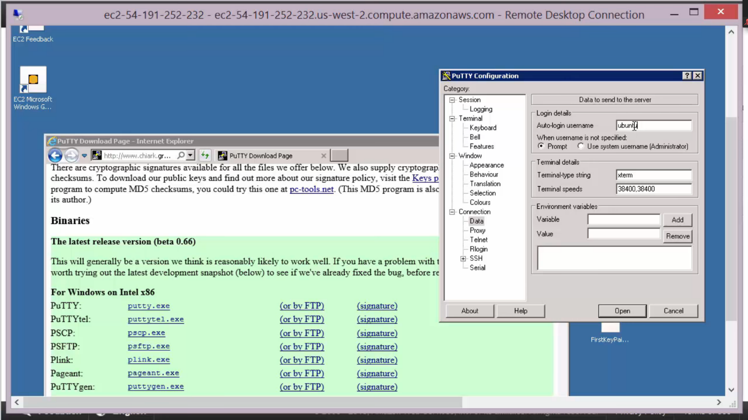

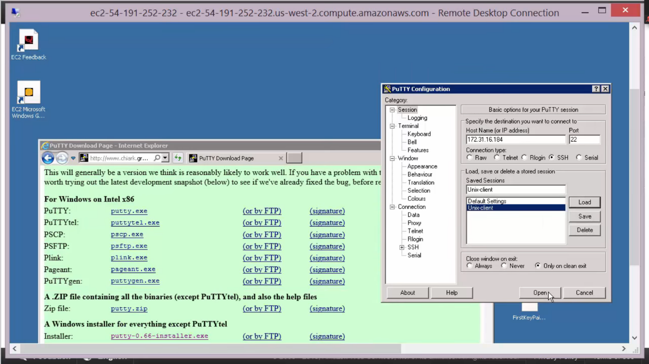

T

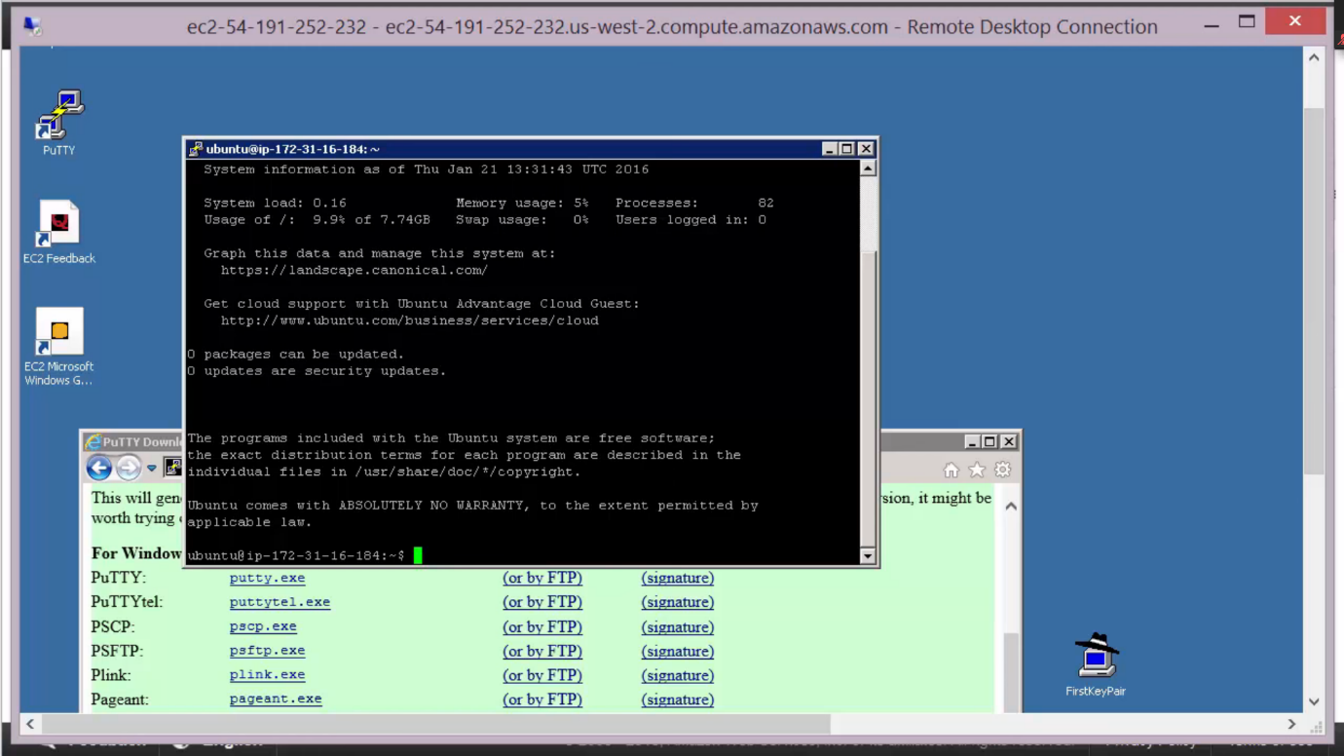

**After that we can see how the connected established between 2 instances**

**Module 9:**

**Different between terminate and stop**

**Stop just stops the instance, but whenever we want we can restart it again,**

**We wont be charged.**

**Teminating: Here we will be completely destroying our instance and deletes entire created resources. Wont be charged money.**

**Module 10:**

**Billing and cost management:**

**Click on billing dash board right top to see usage and purchase activity**

